DAY – 15 (22.06.2024)

1. Write a program to perform Selection sort and estimate time Complexity

Estimate the time iteration for the following set of numbers.

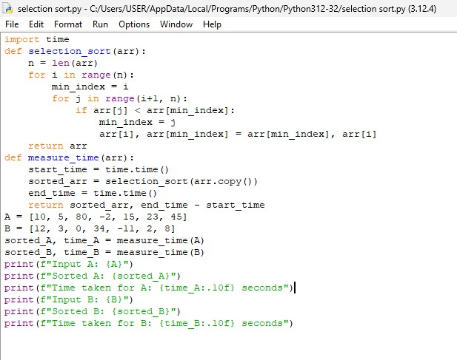

2. A [**perfect number**](https://en.wikipedia.org/wiki/Perfect_number) is a **positive integer** that is equal to the sum of its **positive divisors**, excluding the number itself. A **divisor** of an integer x is an integer that can divide x evenly.Given an integer n, return true*if*n*is a perfect number, otherwise return*false.

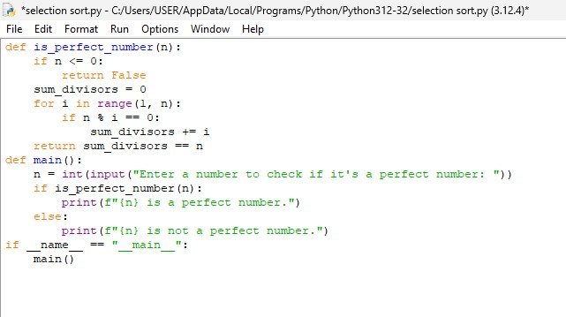

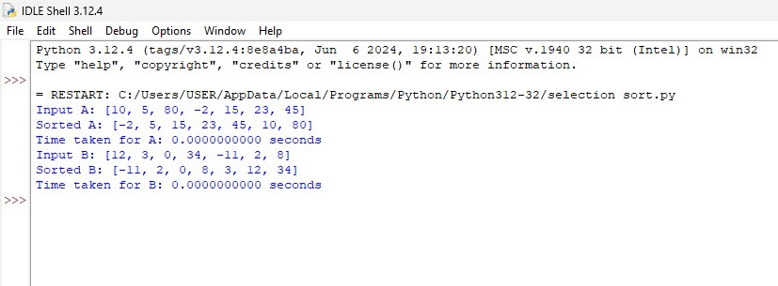

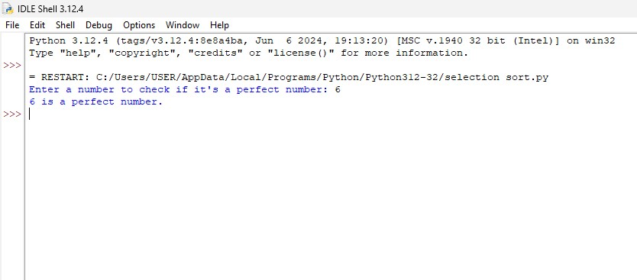

3. Write a [Program to find even Sum of Fibonacci Series Till number N](https://www.geeksforgeeks.org/java-program-to-find-sum-of-fibonacci-series-numbers-of-first-n-even-indexes/)?

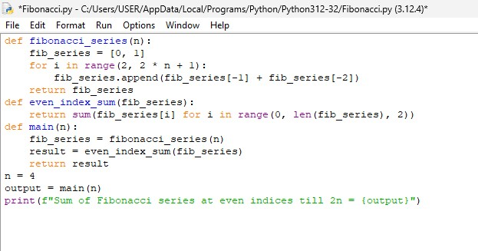

4. Write a program to perform Quick sort and estimate time complexity

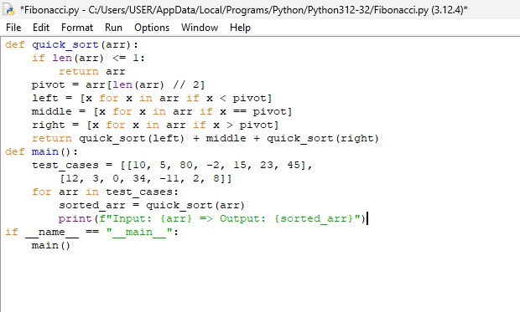5. Write a program to print first 2 minimum values from the numbers in below list.

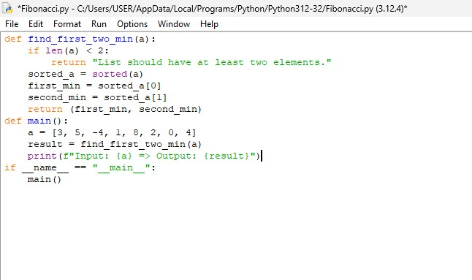

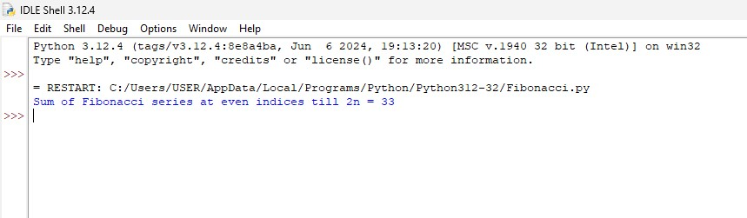

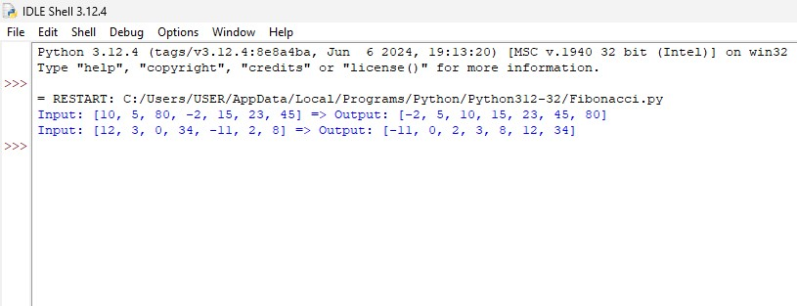

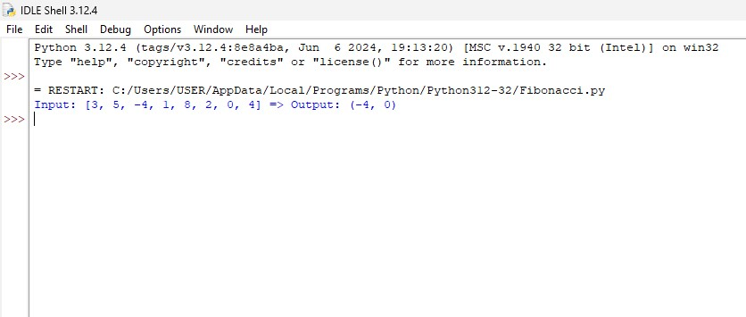

6. Write a program to perform Bubble sort and estimate time Complexity for n values.

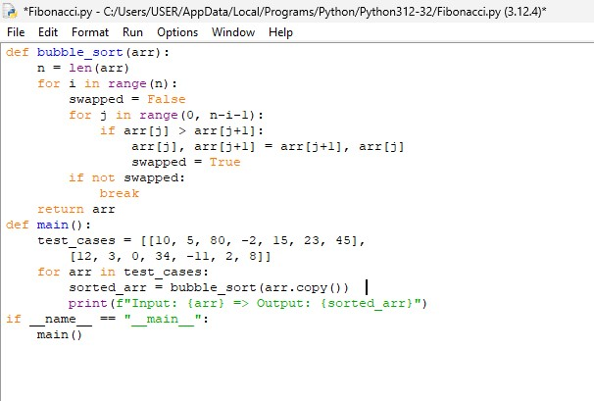

7. Given a sorted array keys[0.. n-1] of search keys and an array freq[0.. n-1] of frequency counts, where freq[i] is the number of searches to keys[i]. Construct a binary search tree of all keys such that the total cost of all the searches is as small as possible.

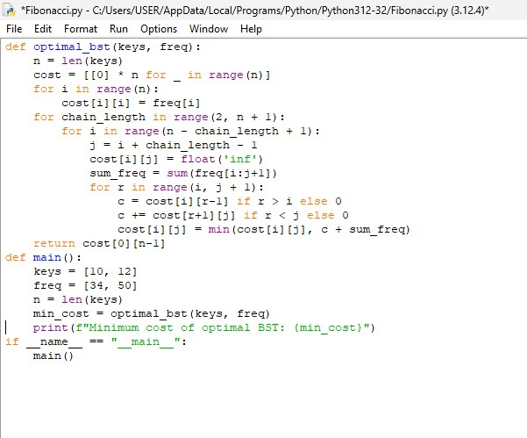

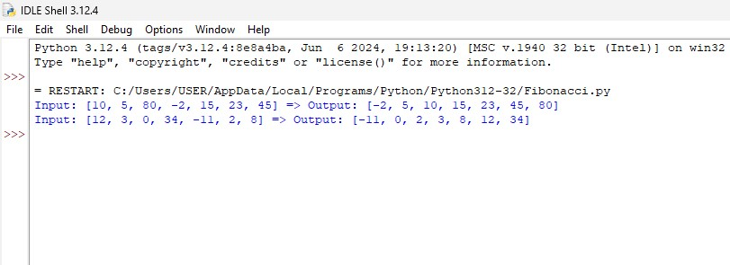

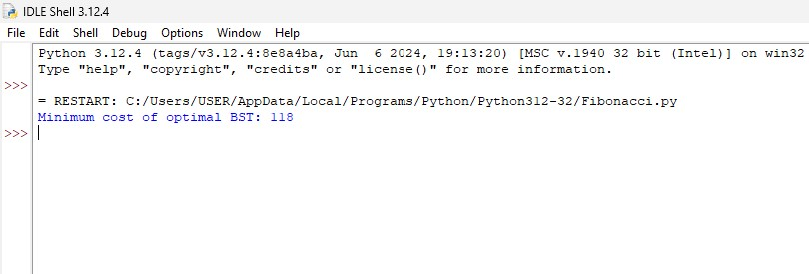

8. Write a program to perform permutation of an array of integers and make all the arrangement are to be in possible sequence.

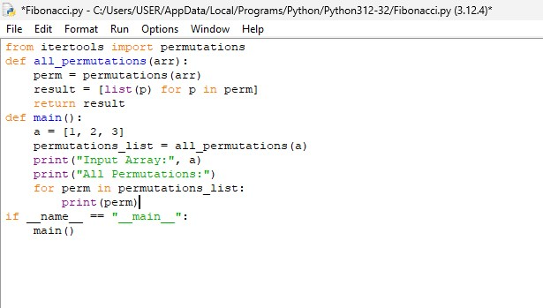

9. Write a program to perform Strassen’s Matrix Multiplication for the 2*2 matrix elements.Find its time complexity.

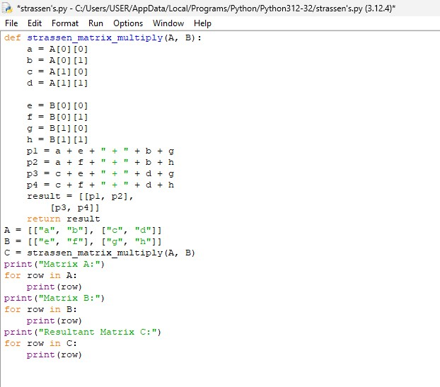

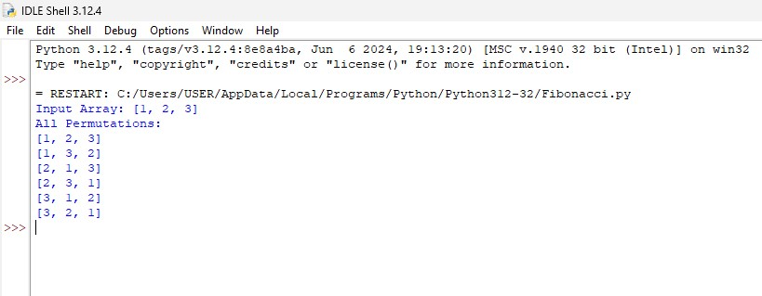

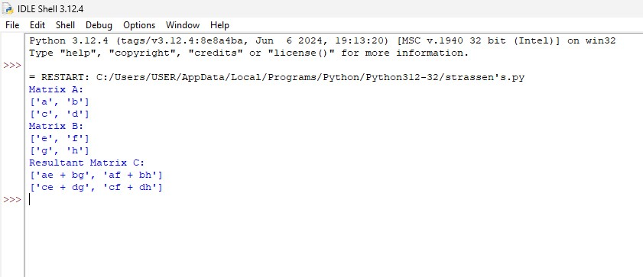

10. Write a program to insert a number in a list

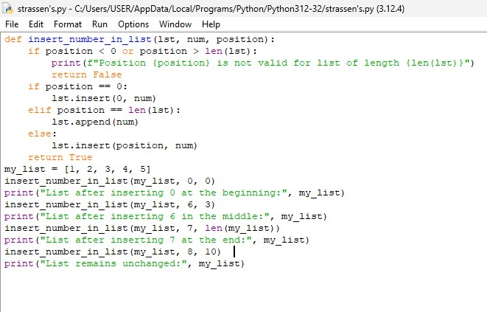

11. Write a program to perform linear search and estimate time complexity. Compute the amount of time for completion.

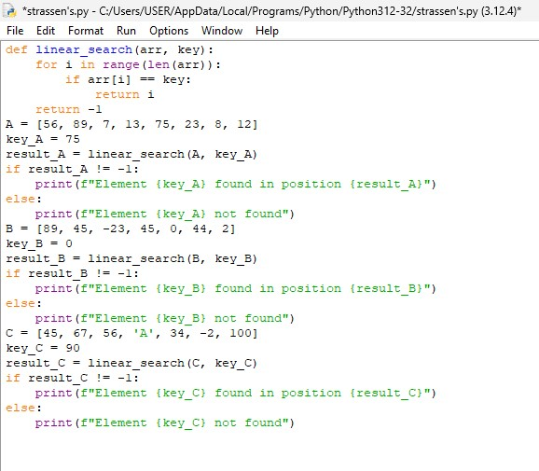

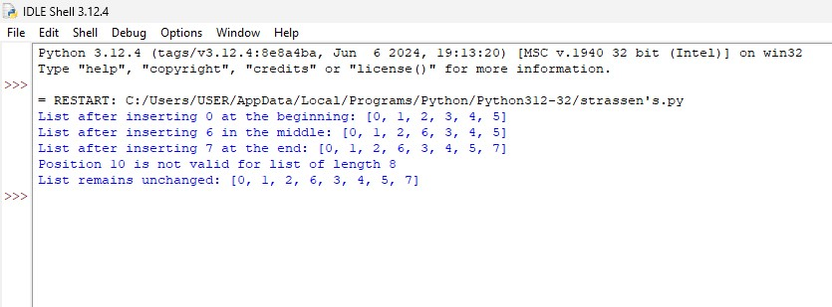

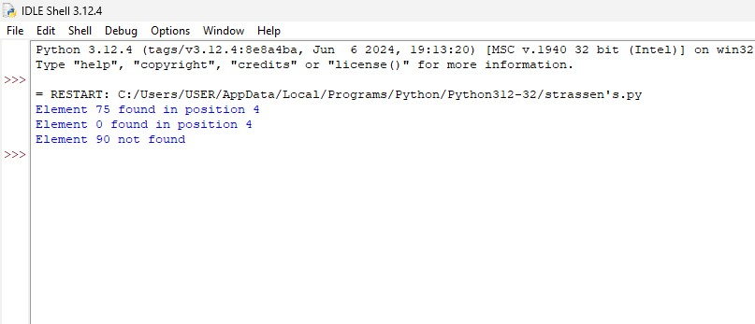

12. Write a program to find the GCD of two numbers. Find time complexity if recursion is

used Perform the test cases

